Fall 2023

MRD: Dollar Tracker

VISION

For personal finance enthusiasts, young professionals, entrepreneurs, and families seeking an effective way to manage their money and who must overcome financial disorganization, our Dollar Tracker is a new personal finance management app that provides a consolidated platform that helps you take control of your money. Dollar Tracker offers a user-centric, all-in-one solution by effortlessly capturing, categorizing, and tracking financial transactions, while offering customizable categories and intelligent budgeting features. Through seamless integration with multiple accounts, we simplify both personal and business finance management.

MOTIVATION

The motivation for the Dollar Tracker app stems from the need to provide users with a comprehensive and user-friendly financial management tool. It aims to empower individuals to take control of their finances, manage expenses, and make informed financial decisions. The desire to create a more organized and efficient way for users to track their money and improve their financial well-being is the driving force behind this project.

Customer Segments:

Hypotheses regarding the likely profile of target customer segments may include:

- Emerging Professionals:

  - Demographics: Age 22-35, urban dwellers, tech-savvy.

  - Behaviors: Digital tool users, early in their careers.

  - Attitudes: Concerned about financial independence and future planning.

- Entrepreneurs and Freelancers:

  - Demographics: Business owners, self-employed.

  - Behaviors: Irregular income streams, managing personal and business finances.

  - Attitudes: Seek comprehensive financial solutions for both business and personal needs.
Fall 2023

- Families and Parents:

  - Demographics: Families with children, single parents.

  - Behaviors: Complex financial needs, budgeting for childcare and education.

  - Attitudes: Interested in family budgeting and future planning.

Unmet Needs:

Hypotheses regarding unmet needs may include:

- Emerging Professionals:
Need: Guidance on managing loans and saving.
Pain: Struggling with financial independence and financial expectations.

- Entrepreneurs and Freelancers:

Need: Comprehensive financial management for both personal and business finances.

Pain: Juggling multiple accounts and complex income streams.

- Families and Parents:

Need: Tools for family budgeting and planning for children's education.

Pain: Balancing family finances, savings, and investment.

Evidence for Unmet Needs:

To validate the unmet needs of our target customer segments, we conducted user surveys and interviews with individuals from various demographic groups. Here's an example of the evidence we collected:

User Interview Excerpt:

Interviewee: John (Age 30), a young professional.

Unmet Need: Guidance on managing loans and financial independence.

Evidence:

John shared that he recently moved to a new city for work, and he's struggling to manage his finances independently.

He expressed his need for a tool that not only tracks expenses but also provides financial advice tailored to his specific situation.

John mentioned that existing apps like Mint and Expensify focus on expense tracking but lack the guidance aspect he's seeking.

Existing Solutions:

We identified solutions such as Expensify, Mint, and Splitwise and assessed their suitability for comprehensive personal financial management. Here's our analysis:
Fall 2023

Expensify:

Expensify is primarily designed for business expense tracking and report generation.

It may not be the best choice for personal budgeting because it lacks features like budget customization and financial advice.

Mint:

Mint is a well-known budgeting and cost tracking tool but offers limited flexibility in customizing expense categories.

The free version of Mint displays ads, which can be intrusive for some users.

Splitwise:

Splitwise is designed for splitting expenses among friends or roommates, not for individual personal finance management.

It lacks comprehensive budgeting features.

Evidence for Existing Solutions:

To validate our hypotheses about existing solutions, we examined user reviews, conducted usability testing, and analyzed the features of these platforms. Here's an example of what we found:

Expensify:

User reviews highlighted the complexity of Expensify's interface for personal use, suggesting that it's better suited for business purposes.

Usability testing revealed that personal users often find the corporate-oriented features unnecessary and confusing.

Mint:

Many Mint users mentioned in reviews that the ads in the free version can be disruptive and negatively impact the user experience.

Splitwise:

Our analysis showed that Splitwise's primary focus is on splitting expenses and does not offer the comprehensive budgeting features we are proposing.

This data serves as a basis for our claims about unmet needs and the limitations of existing solutions, reinforcing the potential for our Dollar Tracker app to address these shortcomings effectively.

Differentiation:

The Dollar Tracker app distinguishes itself from the competition with a variety of cutting-edge features made to meet a variety of money management requirements. By utilizing artificial intelligence, it offers users tailored insights and suggestions to assist them in making wise financial
Fall 2023

decisions. Furthermore, the app is a great option for foreign users who have assets or transactions in other currencies because it enables multi-currency capabilities. The software has a secure document management function that enables users to save and retrieve critical documents safely, ensuring that users can maintain the organization of their financial papers. Security and privacy are of utmost importance, and the software takes strong precautions to protect user information. In addition, it makes joint budgeting easier, which makes it a great option for families or business partners who wish to handle money cooperatively. The software allows users to track their investment portfolios in real time if they are interested in investing. The software uses gamification features to make financial management more entertaining and to motivate users to make prudent investments and save money. Last but not least, Dollar Tracker is a flexible solution for individuals, families, business owners, and investors since it provides configurable reporting choices that let users create financial reports catered to their own needs.

Why Now:

The increasing prevalence of smartphones and digital tools, coupled with users' growing need for efficient financial management, makes this opportunity timely. Furthermore, advancements in technology enable real-time financial tracking and analysis.

USE CASES

Use Case 1: Emerging Professionals

Persona: Sarah, a 28-year-old professional living in the city.

Scenario: Monthly Budgeting

Sarah logs into the Dollar Tracker app.

- She navigates to the "Monthly Budget" feature and inputs her monthly income.

- The app automatically categorizes her past expenses from various linked accounts and provides an overview of her spending patterns.

- Sarah customizes her budget categories, allocating specific amounts for groceries, utilities, rent, and savings.

- She sets financial goals, such as saving for a vacation and reducing dining-out expenses.

- The app provides real-time notifications and alerts if she exceeds her budget in any category.

- At the end of the month, the app generates a summary with graphs showing her actual spending versus the budgeted amounts.

- Sarah can easily see where she needs to adjust her spending and make more informed financial decisions.
Fall 2023

Use Case 2: Entrepreneur and Freelancer

Persona: Alex, a self-employed graphic designer.

Scenario: Expense Management for Business and Personal Finances

- Alex accesses the Dollar Tracker app and switches between his personal and business profiles.

- For his business, he scans and uploads receipts for client-related expenses, categorizes them, and generates invoices.

- The app integrates with his business bank account and credit card to automatically categorize and track business income and expenses.

- On the personal side, Alex manages his monthly bills and expenses, including rent, utilities, and car payments.

- He allocates funds to his savings goals for both personal and business needs.

- The app provides a clear overview of his financial health, including cash flow projections for the coming months.

- Alex can effortlessly manage both business and personal finances in a single platform, ensuring nothing falls through the cracks.

Use Case 3: Parents and Families

Persona: Emily and John, a couple with two children.

Scenario: Family Budgeting and Education Planning

- Emily and John access the Dollar Tracker app using a shared family account.

- They set up sub-accounts for each family member, including one for their children.

- The app helps them allocate money to specific categories, such as childcare, education, and family vacations.

- Emily and John receive reminders for upcoming bills and can easily pay them through the app.

- They track their progress toward saving for their children's education, and the app provides investment advice.

- The couple can easily split expenses for family vacations or birthday parties.

- The app keeps them organized and prepared for family financial milestones, such as saving for college.

- These use cases illustrate how the Dollar Tracker app caters to the specific needs of various customer segments, offering tailored solutions to simplify and enhance their financial management experience.
Fall 2023

MARKET SIZE

Target Market:

Population Data:

Assumption 1: Obtain recent population data for Boston. According to the U.S. Census Bureau, Boston's estimated population is around 700,000.

Adoption Rate:

Assumption 2: Estimate the adoption rate within this specific market. For this example, let's assume a conservative adoption rate of 8%.

Frequency of Expense Tracking:

Consider how often users will track their expenses. Let's assume users will track their expenses monthly.

Average Monthly Subscription Fee:

Assumption 3: Determine the average monthly subscription fee. We'll assume it's $5, which is a reasonable price point.

Market Potential:

Calculating the market potential for the expense tracking app in Boston:

Total Potential Users = Estimated Population x Adoption Rate = 700,000 x 0.08 = 56,000 users Monthly Revenue = Number of Users x Monthly Subscription Fee = 56,000 x $5 = $280,000 per month

Annual Revenue = Monthly Revenue x 12 months = $280,000 x 12 = $3,360,000 per year Based on these specific assumptions for Boston, the expense tracking app targeting working professionals, small business owners, and students has a market potential of approximately $3.36 million per year.
Fall 2023

CAVEATS / RISKS / KEY DEPENDENCIES

Risk |  | Mitigation Plan
Privacy Concerns |  | Implement stringent security measures like
Risk of privacy breaches and data security threats |  | encryption, |  | two-factor |  | authentication, |  |  | and
due to sensitive financial data. Users may | be | conduct regular security audits to safeguard
hesitant to share financial information. |  | user data.
Legal and Compliance Risks |  | Conduct in-depth research and seek legal
Risk of non-compliance with financial regulations, |  | counsel | to | ensure | full |  | compliance |  | with
leading to fines and legal actions. Varies depending |  | financial | laws and |  | regulations |  |  | in target
on regions of operation. |  | markets.
Interdependencies with Third-Party Services |  | Establish close collaboration with third-party
The app relies on third-party services (e.g., bank |  | providers and develop contingency plans to
APIs) for real-time financial data, and disruptions or |  | manage | any | changes |  | or | outages | in | these
changes in these services can impact functionality. |  | services.
Rapid Technological Changes |  | Stay updated with technological trends,
Risk of technological obsolescence as new |  | continuously |  | improve |  | app features, |  |  | and
innovations emerge. |  | remain competitive in the market.
User Trust and Adoption |  | Implement effective |  |  | marketing |  |  | strategies,
The challenge of gaining users' trust and |  | transparent communication, and excellent
encouraging them to link their financial accounts. |  | user support to build trust and drive adoption.
Monetization Strategy |  | Create a mitigation plan that includes periodic
Success of the app's monetization strategy relies on |  | user feedback and the ability to adjust pricing
user willingness to pay for premium features | or | and subscription models as needed.
tolerate ads. Rejection of these options may impact
revenue.
Platform Compatibility |  | Regularly test and update the app to ensure
Ensuring a seamless experience on various |  | compatibility and responsiveness to user
smartphone platforms and devices (e.g., Android |  | feedback
and iOS) is essential to prevent user dissatisfaction.

Fall 2023

STRATEGIC CONSIDERATIONS

There are a number of other expense tracker apps on the market, such as Mint, Expensify, and Splitwise. However, the dollar tracker app differentiates itself from the competition by focusing on a specific niche like parents in Boston and by offering unique features like integration with other financial apps.

The target customer segment for the dollar tracker app is parents, small business owners, freelancers and students in Boston. This segment was chosen because these groups are most likely to benefit from using a dollar tracker app to manage their finances.

We are using a push-pull strategy for the dollar tracker app in Boston. The push strategy involves promoting the app to potential users through marketing and advertising. The pull strategy involves making the app so attractive that users are drawn to it.

Push: The dollar tracker app creates a social media campaign targeting parents, small business owners, freelancers, and students in Boston. The campaign highlights the benefits of the app, such as its ease of use and its ability to help users save money.

Pull: The dollar tracker app offers a free trial period so that users can try the app before they commit to subscribing. The app also offers a variety of features that are specifically tailored to the needs of the Boston market, such as tracking the cost of living in Boston and providing

TEAM MEMBERS

- Shreya Pagadala

Master of Science in Data Analytics pagadala.sh@northeastern.edu
- Ram Swaroop Reddy Aleti

Master of Science in Data Analytics aleti.r@northeastern.edu

Fall 2023

GO/NO GO RECOMMENDATION

Recommendation GO

Our team recommends a GO! based on all the information provided and the data we gathered from surveys and interviews. This service undoubtedly fills a need, and the scale of the market validates our strategy.

Understanding the needs of different user groups for financial tracking was possible thanks to the user interviews conducted as part of the Dollar Tracker project. The goal of improved financial management is shared by all of these users, including professors, independent contractors, small business owners, and students. Their unique financial circumstances, which included low student budgets, unpredictable freelance income, and the difficulties of keeping both personal and corporate accounts, made them realize that customization was necessary. The focus was on streamlining the process of identifying personal from business spending and integrating bank accounts. Customers also agreed that time efficiency through automation and instant insights were of the biggest significance, citing parental controls and personalized spending categories as essential benefits.

A recurrent issue emerged from the conversations with many participants: people are searching for improved financial management solutions. The customers now use spreadsheets and pre-existing finance applications to track their expenses; some regard these apps to be somewhat beneficial but lacking in flexibility. Their primary goal is to provide a financial management application that can suit the needs of numerous user groups, such as parents, small business owners, students, and freelancers, while also being able to budget and categorize spending.

The current financial tracking techniques are listed below. We also included important information and requirements for these consumers based on our user interviews.
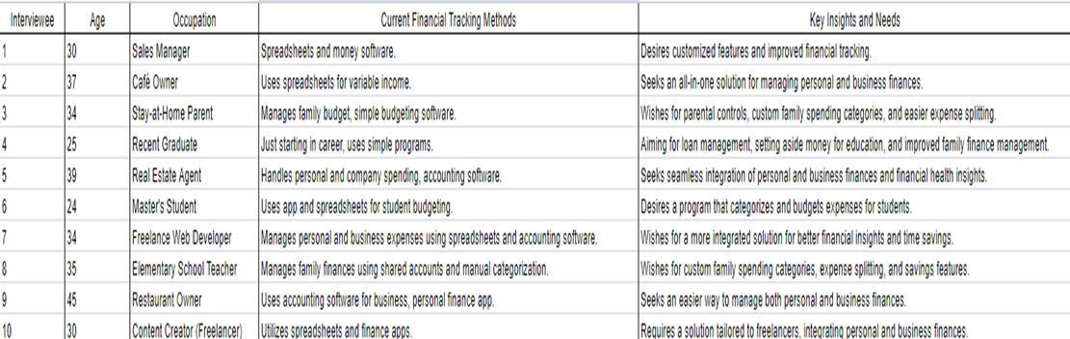
Fall 2023

The tracking tactics used by the users who were interviewed are listed in the table along with a count for each strategy. Spreadsheets are the most popular technique for consumers to monitor their spending, with 12 people using this strategy. Apps for budgeting are the second most popular category, with six users. One user decides to manually record data in a notepad. Some users combine multiple strategies, including using spreadsheets and accounting software or spreadsheets plus an app for budgeting. The table offers insights into the different ways that customers monitor their expenses, including data from 29 users overall.
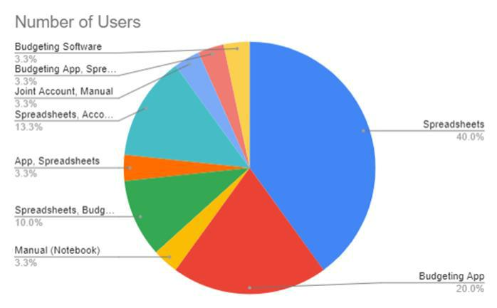

For different user categories, Dollar Tracker will provide tailored features like personalized classification, simple budgeting, and targeted financial solutions. Through the use of tailored and practical financial tools, the initiative seeks to improve user control over their finances by streamlining spending tracking and management.

The knowledge gathered from these interviews highlights how crucial it was to create Dollar Tracker as a flexible, user-friendly financial tool that can meet a variety of financial management requirements. The goal of the Dollar Tracker project is to develop an app that meets the various needs and preferences of users with regard to money problems. These interviews have produced priceless insights that closely correspond with the goals of the project. Program priorities include personalization, easy integration of personal and business money, flexible category administration, parental restrictions, and time-saving features.
Fall 2023

The ultimate purpose of Dollar Tracker is to provide an all-inclusive financial management system that can be tailored to the specific financial needs of any user, be they a parent, small business owner, freelancer, or student. It is intended to provide users with a tool that not only makes financial tracking easier but also provides intelligent recommendations by catering to these unique needs and preferences. Given these strong arguments, the suggestion is a resounding "go" indicating that the Dollar Tracker app development can move forward.

